

**DHA SUFFA UNIVERSITY**

**Department of Computer Science**

**CS-1101L**

**Applications of Information and Communication Technologies Lab**

**Fall -2024**

**[Black And White]**

**Only shopping store**

**Project Report By**

**[ROHIT RAJ ] [CS241149]**

**Group Members:**

[SHIVAM KUMAR] [CS241200]

[SOORAJ SHIVANI] [CS241208]

**Submission Date:**   
**17th Jan. 2025**

**Table of Contents**

# Introduction

# 2. Requirements Analysis

# 3. Design

# 4. Implementation

# 5. Deployment

# 6. ****Future Enhancements****

# 7. ****References****

# 8. Roles and Responsibilities Distribution

### 1. ****Introduction****

* **Project Overview:** This project is a web-based **eCommerce platform** designed to provide users with a seamless online shopping experience. It will allow businesses to showcase their products, manage inventory, and process transactions, while customers can browse, compare, and purchase products easily from anywhere. The platform will also feature advanced tools like product recommendations, user reviews, and secure payment gateways.
* **Purpose and Scope:** The purpose of the eCommerce website is to bridge the gap between businesses and their customers in a fast-paced digital world. By providing an online presence for businesses, the platform makes it easy to reach a wider audience while offering customers a convenient and secure way to shop.
* **Scope:**  
  The platform will cater to small and medium-sized businesses, enabling them to:
* List and manage their product catalogs.
* Handle orders and payments efficiently.
* Engage with customers via feedback and reviews.

· **Audience:**

· **Target Users:**

· **Shoppers:** Individuals seeking a reliable and user-friendly platform to shop online for a variety of products, ranging from electronics to clothing and home goods.

· **Business Owners:** Small and medium-sized enterprises (SMEs) looking to establish or enhance their digital presence and increase sales.

· **Stakeholders:**

Website administrators managing the platform's functionality.

* Payment service providers ensuring secure financial transactions.
* Delivery partners supporting logistics and order fulfillment.

· **Relevance:**

**Significance of the Project:**  
 In today's fast-paced digital economy, online shopping has become an essential service for businesses and customers alike. This eCommerce website:

* Empowers businesses to adapt to the growing demand for online shopping.
* Provides a secure and efficient platform for customers to shop anytime, anywhere.
* Helps local and small-scale businesses compete with larger enterprises by leveraging technology.
* Promotes convenience, time savings, and customer satisfaction.

### 2. ****Requirements Analysis****

**Functional Requirements:**

**User Authentication:**

* Login and registration system using email/username and password.
* Multi-factor authentication (MFA) for added security.
* Password recovery/reset functionality.
* **Technological Requirements:**

**Programming Languages:**

* Frontend: JavaScript, , or frameworks HTML5,CSS ,JAVA SCRIPT.

**Software:**

· **Visual studio Code.**

### 3. ****Design****

* **UI Design:** Screenshots of the user interface.

***[Website screenshots]***

[HOME PAGE]

(Black and white.html:)





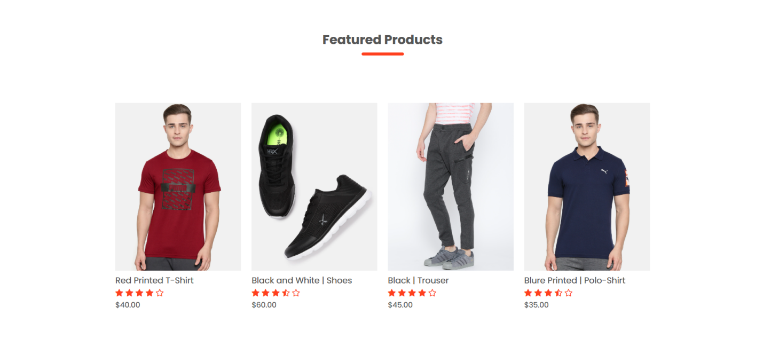

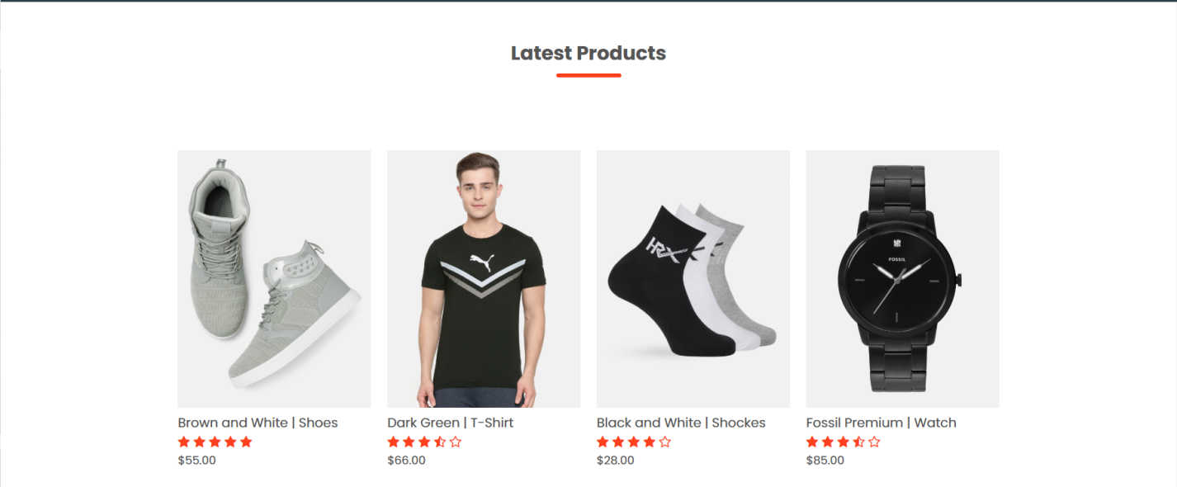

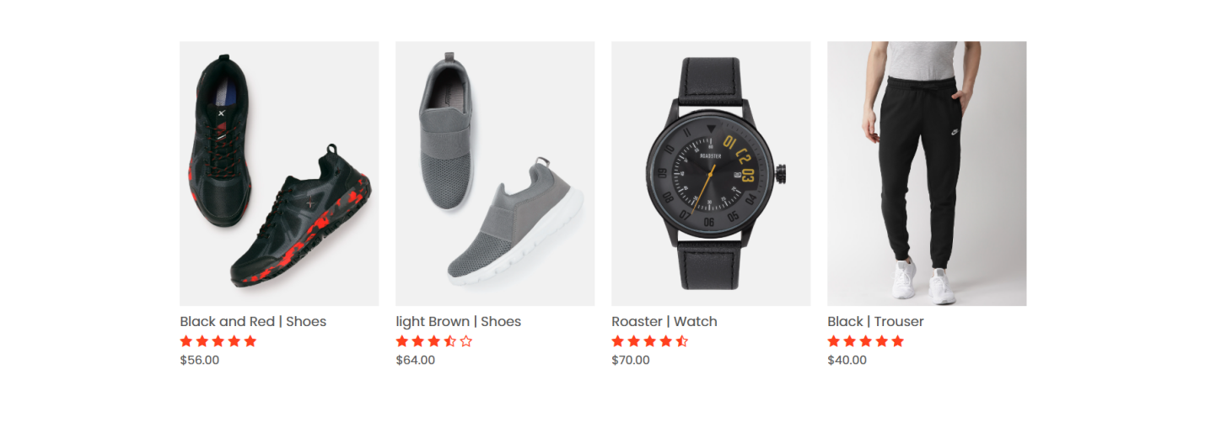

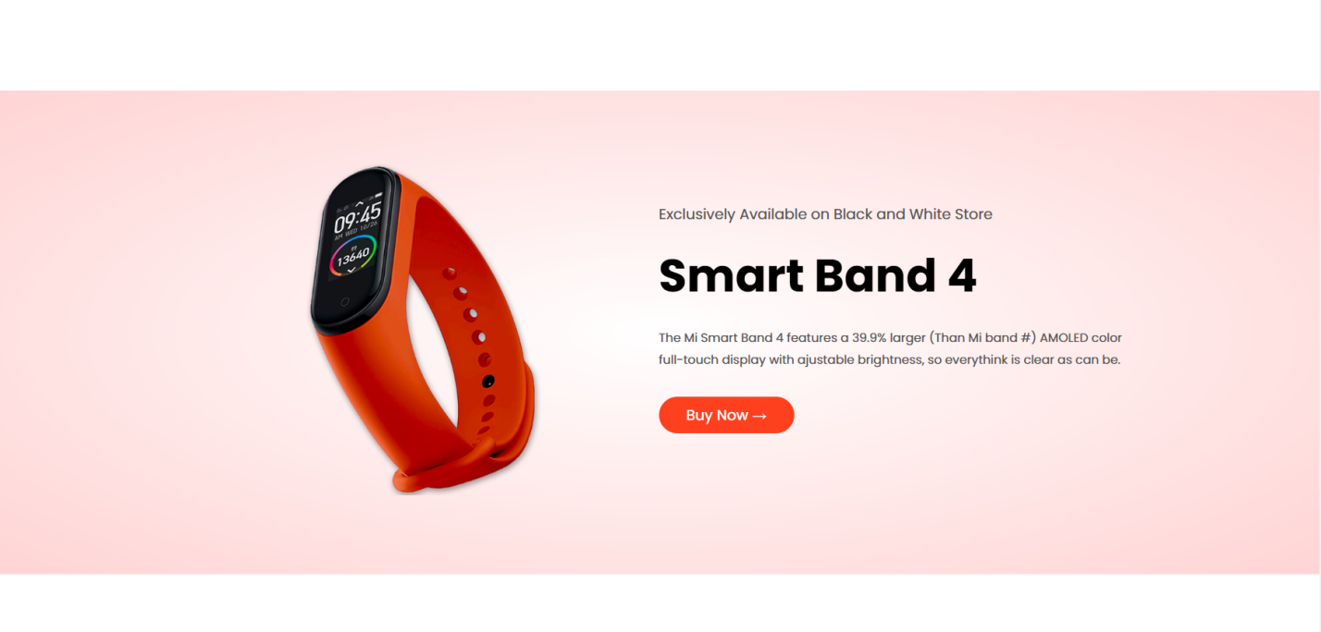

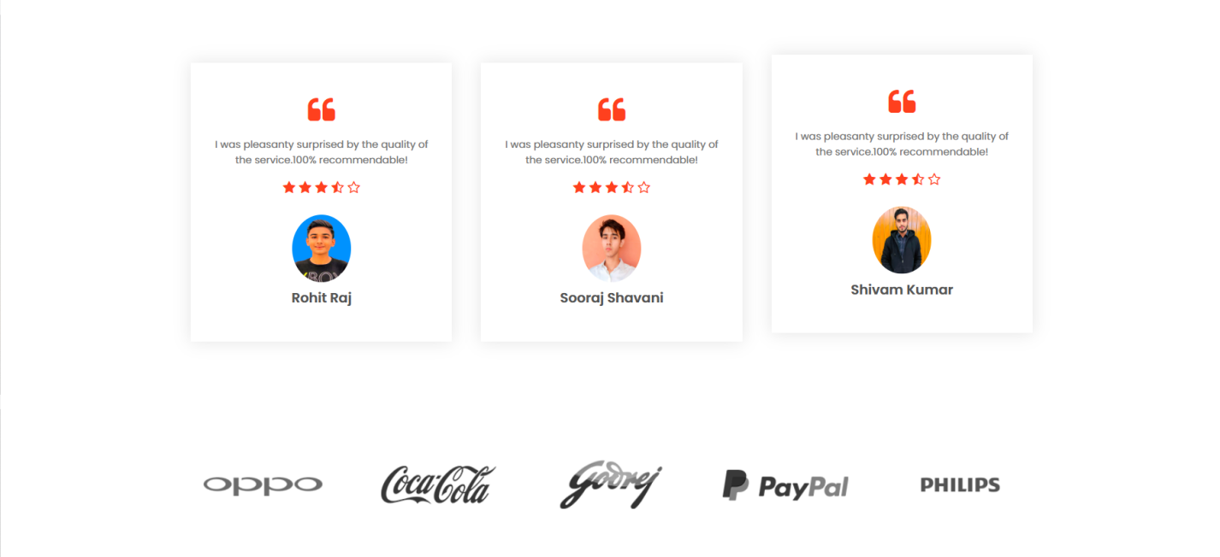



[PRODUCT PAGE]

(product.html):

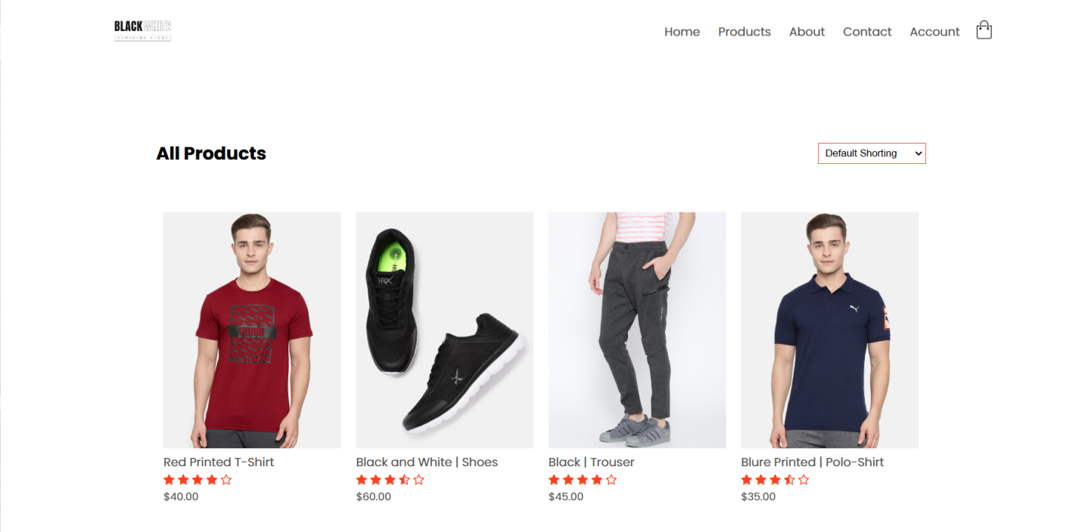

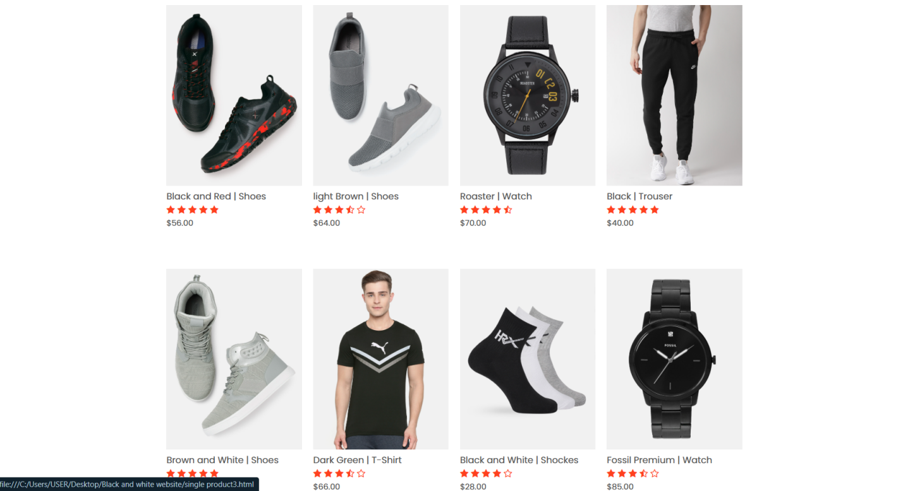

[ABOUT US]

(About us.html)





[CONTACT US]

(contact.html)

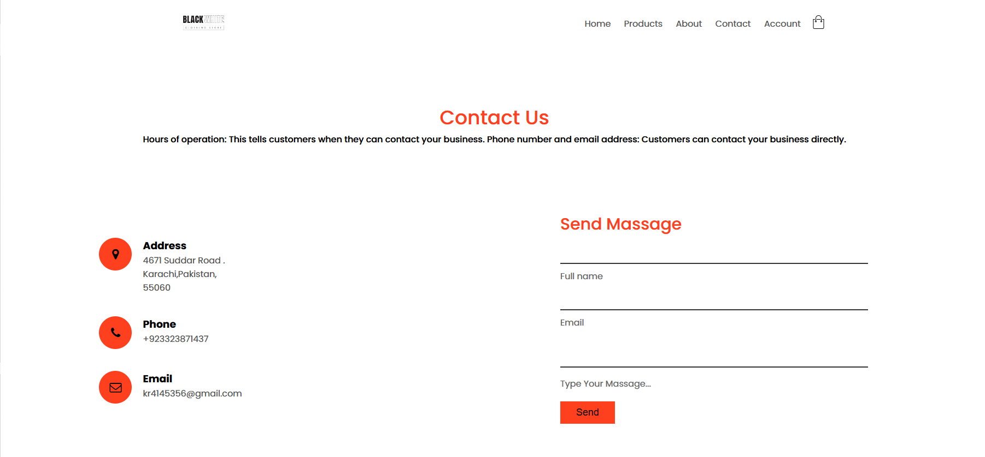



[ACCOUNT PAGE]:

(Account.html):

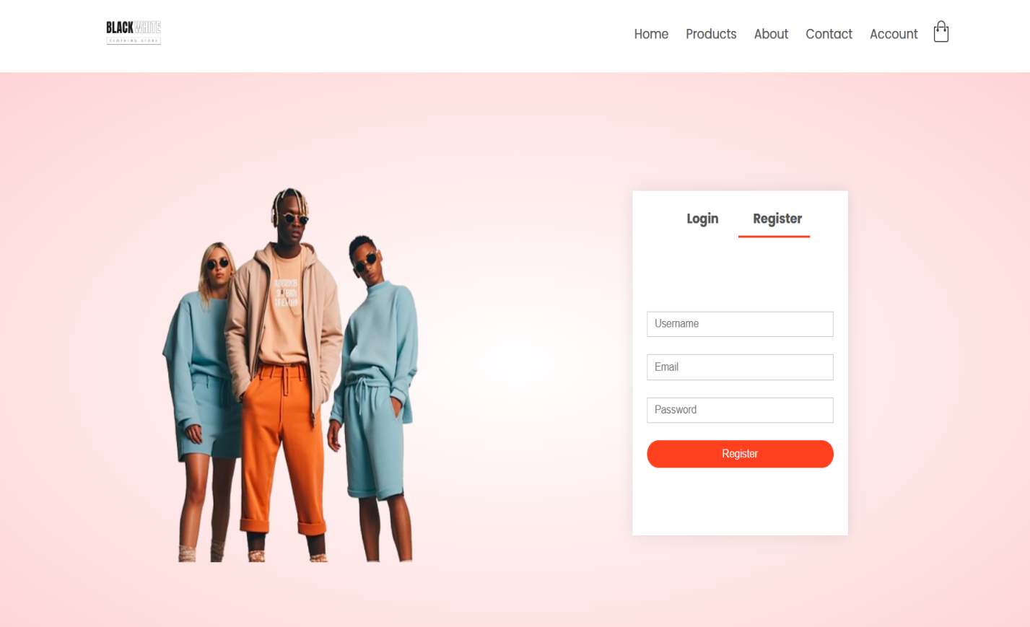



[cart page]

(cart.html)

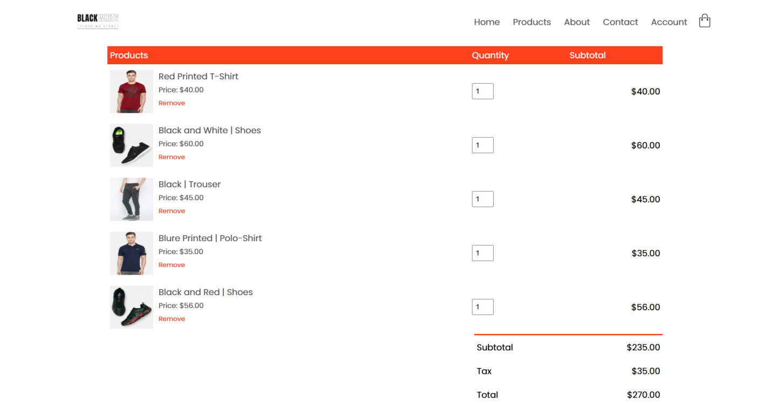



### 4. ****Implementation****

* **Development Tools and Technologies:**
  + - Programming languages:
      * Frontend: HTML, CSS, JavaScript..
    - Libraries:
      * Frontend: HTML5 <!DOCTYPE html>, CSS for styling.
* **Modules and Features:**

· **Functionality:**

* Handles user login, registration, and logout.

· **Integration:**

* Sends email or SMS for MFA or password recovery.

### 5. ****Deployment****

### Live Website GitHub Repository

### GitHub Repository: https://github.com/rohitkhatri046/Black-And-White.git

### Live Website: <https://rohitkhatri046.github.io/Black-And-White/>

### 6. ****Future Enhancements****

#### ****1. Advanced User Experience:****

* **Responsive Design:**  
  Ensure the website is fully responsive on all devices, including tablets and smartphones.

#### ****2. User Authentication:****

* Add a **login and registration system** for personalized shopping experiences.
* Implement **password recovery/reset functionality.**

#### ****3. Product Reviews and Ratings:****

* Allow users to submit reviews and rate products.
* Display an average rating on the product page.

### 7. ****References****

* Documentation, tutorials, articles, or tools referred to during development

**Roles and Responsibilities Distribution**

|  |  |  |  |
| --- | --- | --- | --- |
| **S #** | **Reg. #** | **Name** | **Tasks** |
| 1. | Group Lead |  |  |
| 2. | Member 1 |  |  |
| 3. | Member 2 |  |  |